The Operation

The Fontan operation can be done in several different ways. At the Royal Children's Hospital there have been three main ways of ensuring as much blood flow to the lungs as possible.

1. Extracardiac Fontan
  - The superior vena cava is connected to the right pulmonary artery (this may have been done at an earlier 'bi-directional cavo-pulmonary shunt' operation)
  - The inferior vena cava is re-routed through a Gore-Tex tube (conduit), which runs outside the heart and is connected to the Pulmonary Arteries.
  - The atrial septum is removed (this may have been done already at previous surgery).
  - Blood returns via the pulmonary veins into the left atrium and may also pass to the right atrium freely > ventricle > Aorta > body.
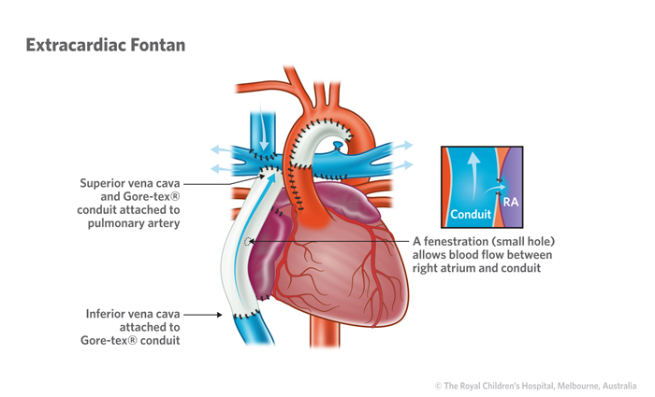

2. Lateral tunnel Fontan
  - Venous return is redirected to the pulmonary artery and into the lungs by joining the superior vena cava and the inferior vena cava by a large patch that creates a tunnel through the right atrium.
  - The vena cavas are then connected directly to the pulmonary arteries above the heart.
  - The atrial septum is removed.
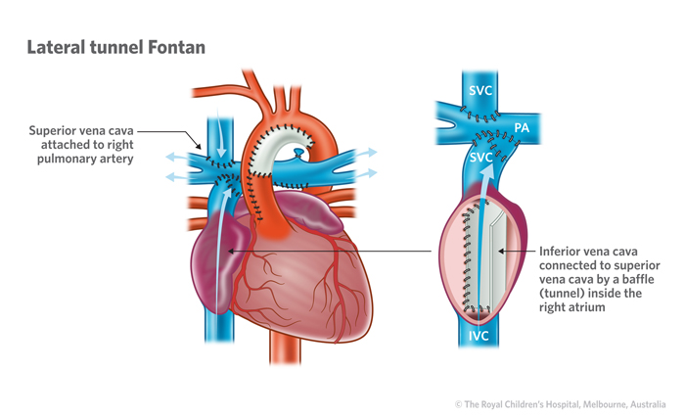
  - Blood returns via the pulmonary veins into the now independent left atrium > ventricle > Aorta > body.

3. Atriopulmonary Connection (now rarely used)
  - The right atrium is connected to the pulmonary artery.
  - If the tricuspid valve is present it needs to be closed off with a patch (to prevent blood flowing into the ventricle).
  - The atrial septal defect is closed.
  - Blood now flows from the superior and inferior vena cava through the right atrium and into the pulmonary arteries.
  - Blood returns via the pulmonary veins into the left atrium > ventricle > aorta > body.

https://www.rch.org.au/cardiology/parent_info/Information_for_patients_and_parents_about_the_Fontan_Operation/#the-operation

