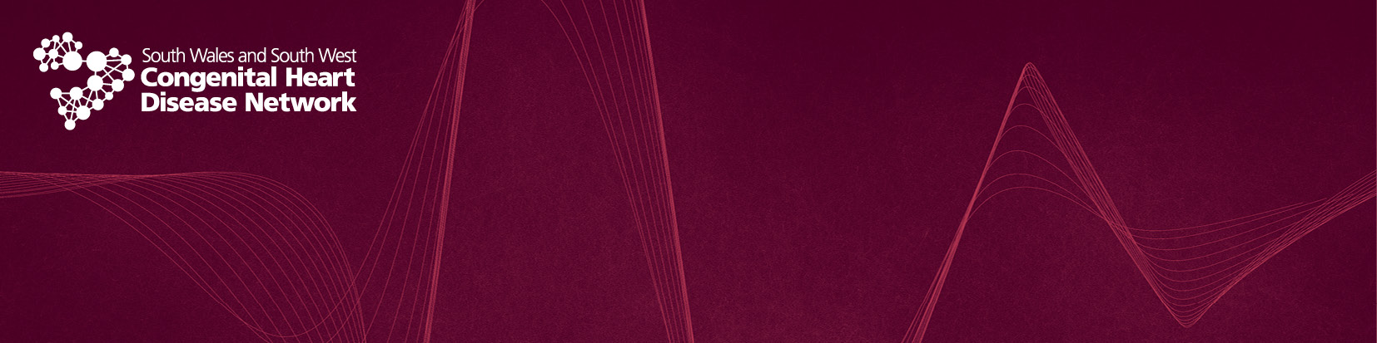
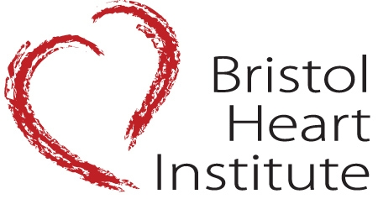
Save the date!
Adult Congenital Heart Disease Study Day

Tuesday October 1st 2019
Lecture Theatre 1 Education Centre
University Hospitals Bristol, BS2 8AE
100 places available
For further information please contact: Sheena.Vernon@uhbristol.nhs.uk
Morwenna.Bugg@uhbristol.nhs.uk
Booking forms to follow with programme

